**Sona M K**

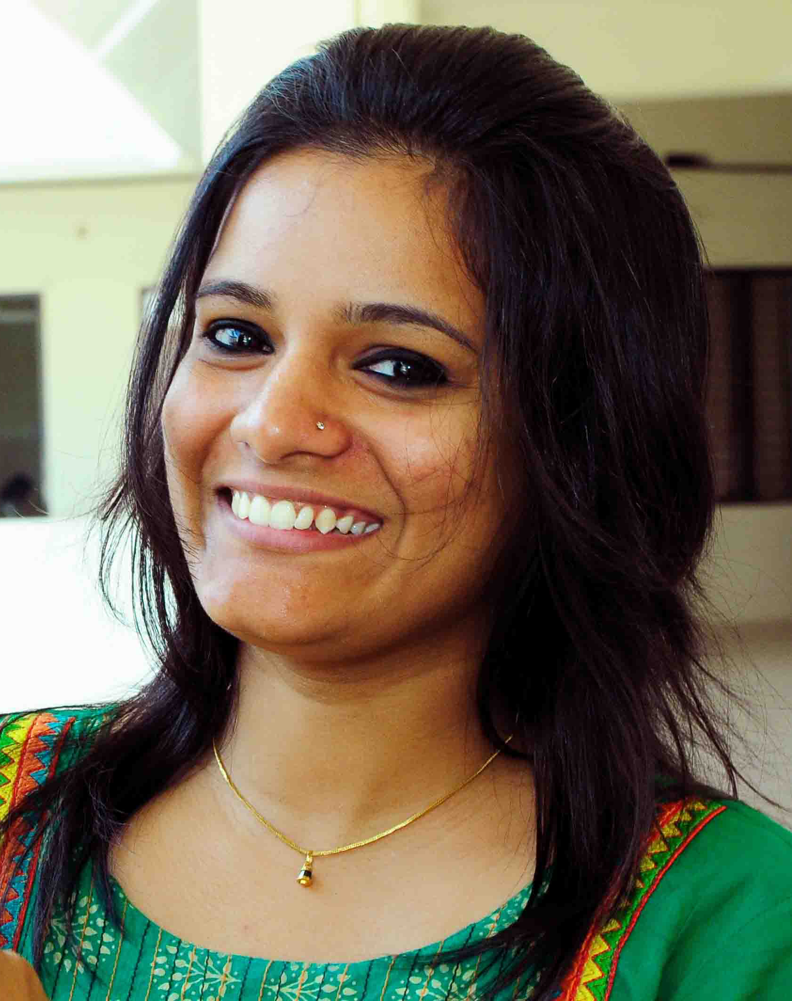

Mob: 8129741083 - Email:sonamk101990@gmail.com

**Summary**

Dedicated in Human Resource & Administration department focused on developing efficient processes using knowledge of recruiting, employee relations, training and development , office Administration and professional ISO Management Representative which have remarkable experience in implementing, administering and internal auditing an ISO 9001 Quality Management Systems, can be fully utilized for the bettering of the establishment.

**Highlights**

* Hiring, Retention
* Organizational administration
* Statutory Compliance
* Staffs Personal records maintenance
* Human Resource audit
* HR policies & procedures expertise
* v
* Induction & Orientation
* Staff training & Development
* Compensation/Payroll
* Employee relations

**Accomplishments**

* Developing targeted outreach recruitment programs to recruit the best talent and meet all departmental hiring requirements by creating user- friendly application forms to be used by the organization during staff recruitment and interviewing.
* Experiencing in exploring and developing HR operations to the utmost satisfaction of organizational requirement and thereby achieving desired goals
* Implementing ISO 9001-2015 Quality Management Systems for the bettering of the establishment.
* Implementing an employee performance appraisal system, resulting in increased efficiency during assessment times.

**Experience**

**Manager – HR Oct- 2015 to current**

**Malabar Dental College & Research Centre - Edappal, Malappuram**

* Developed an HR policy & HR manual for MDC & RC
* Lead the HR function of the organization/Institution as a first & single point of for all HR related issues, Co- responsible for all issues received from all staffs including – Teaching staffs both Dental & Medical Doctors & non – teaching staffs
* Responsible for all HR functions and its various verticals.
* Recruitment- both Dental & Medical Doctors & non- teaching staffs
* Induction
* Newly Employee background Verification procedures through Legal Advisor of the institute
* Attendance – Biometric Punching System
* Salary/Payroll
* Increment Procedures
* Statutory compliance- ESI & PF
* Day to day Operations in
* Transportation
* Hostels
* Performance Appraisal
* Evaluate and assess the quality and performance of all staffs - both Dental & Medical Doctors & non- teaching staffs by conducting periodical assessment
* Documentation of all staff’s personal files - both Dental & Medical Doctors & non- teaching staffs
* Plays major role in DCI & KUHS inspections
* Worked as a Management Representative and Implemented ISO 9001-2015 Quality Management Systems for the bettering of the establishment.
* Have a good relationship with labour officers, EPF/ESI authorities to avoid unwanted issues.

**Manager- HR & Administration Jan 2014 to Sep 20 15**

**Wayknow Media Village India Pvt Ltd- Pantheerankavu, Calicut**

* Provide leadership and coordination of company Human Resource functions. Develop and implement corporate Human Resource strategy and programs.
* Responsible for all HR administration functions and its various verticals.
* Recruitment
* Induction
* Attendance – Biometric Punching System
* Salary/Payroll
* Increment Procedures
* Day to day Administration activities with all departments.
* Performance Appraisal – Evaluate and assess the quality and performance of all staffs
* Documentation of all staff’s personal files
* Ensuring the organization structure is aligned and suitably staffed.
* Identifies critical employee training needs across the company and monitors the effectiveness of training.
* Facilitates the development of appropriate organization structures with clearly defined roles and responsibilities and manpower requirements attribution
* Develop and maintain appropriate employment records and systems.

**HR Executive May 2013 to Oct 2013**

**IPIX Solutions Pvt Ltd, Kinfra IT Park- Kakkanchery, Malappuram**

* Lead the HR function of the organization as single point of for all HR related issues, Co- responsible for all issues received from all staffs including
* Identify staff vacancies and recruit , interview, and select applicants
* Attended Job Fairs for recruitment process
* Conduct orientations to foster positive attitude toward organizational objectives
* Dealing with all HR Functions:
* Recruitment – Information Technology & Non – IT candidates
* Performance Appraisal of staffs
* Salary Calculations
* Personal files documentation
* Statutory compliance- ESI & PF
* Exit Interviews

**HR & Admin Executive Dec’11 to May ‘13**

**Thai Groups of Companies, Calicut**

* Handling all HR operations of 15 branches in North Kerala
* Coordination for interviews
* Recruitment- Executives to Manager level
* Issuing offer letters
* Joining docket processing of new joiners.
* Processing of employee salary part and handling employees Statutory Compliances
* To maintain attendance records of employees.
* Recruitment through usage of consultants, employee referrals and job portals and thereby ensuring the timely supply of manpower for critical positions.
* As a first & single point of contact for 15 branches all admin related issues, Co- responsible for all issues received from all branches & their smooth closure.

**Education Credentials**

MBA - Human Resourse Management & Marketing 2012

University of Chennai - RVS Institute of Management Studies, Coimbatore

B.sc - Zoology 2010

- University of Calicut – St. Joseph’s College, Devagiri, Calicut

Plus Two

- Kerala State Board from Calicut Girls V. H .H. S, Calicut, Kerala, 2007

Tenth

- Kerala State Board from Venerini Girls H S S, Calicut, Kerala, 2005

**Certificate/Training**

* Has successfully completed the training program in **CALL CENTRE TRAINING**
* Has successfully completed the course **COMPUTER OPERATION** of duration One Month and has obtained the **Grade B+**
* Participated in **“Out Bound Training”** conducted by **“Break Through”**
* Participated in **“Skill Bridge Training”** conducted by **“24/7”**

**Key Academic Projects/Assignments**

* One month In-plant training at Kerala Soaps Limited, Calicut, Kerala.
* Studied about the functions of various departments in the organization.
* Four months project at Commonwealth Tiles Factory, Feroke, Calicut.
* Studied about the working environmental condition among employees**.**

**Positions Held/Special Achievements**

* Participated in Social Service as a member of N.S.S.
* Organized School Day Events and volunteered for Events at College and University levels.
* Awarded Best Actress in Drama
* Member of CMA (Coimbatore Management Association)

**Personal Info**

* Gender : Female
* Marital Status : Single
* Languages Known : Malayalam, English, Tamil, Hindi
* Address : Paradise,

: Melekunnath house,

: Feroke P.O,

: Calicut- 673631

**Date: Signature**