**Curriculum Vitae**

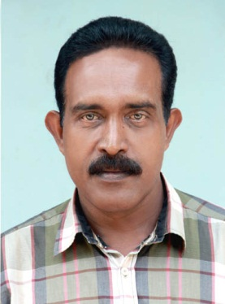

ANISH . S

Sabarisandram, Agasthyacode

Anchal P.O.,Kollam – 691306

**Personal Profile**

Age and date of birth 50, 21st Sept 1966

Nationality : Indian

Sex : Male

Marital Status : Married

Name of father : K. Sukumarapanicker

Address : Sabarisandram, Agasthyacode,

Anchal P.O.,Kollam – 691306

**E-mail** : [anishspanicker@gmail.com](mailto:anishspanicker@gmail.com)

**Contact Tele Nos:**  9446616135, 7025119191 (Mob),0475 2273212(land line)

**Educational Qualification** : M.A. P.G.D.J

**Experience**

Sub editor/Reporter in Keralakaumudi daily and keralakaumudi

Flash midday Kollam and Pathanamthitta (Bureau Chief In Charge,Kerala Kaumudi ) Units from 2001 to 2015

October.

**Proficiency** : , Reporting, Editing, news co-ordination, Content writing, Malayalam and English typing, Proof reading etc.