Resume

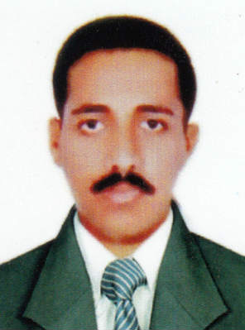
MOHAMMED SHANFI
Mobile: 0091-9562584128
E-mail: shanfimohammed@gmail.com POSITION APPLIED:

Career Objective

I wish to work in growing organization that would help me to explore my potential to the fullest and in the process add value to the organization and also develop my skills and experience.
Educational Qualification

- BA (ENGLISH)- CALICUT UNIVERSITY
- Diploma in Hotel Management : K.M.L.D.C (Govt. of India) 2001
- Diploma in Fire & Safety Eng: D.C.S.F.E( Gov. of India) 2004
- First AID: G.T.S. C –(Abu Dhabi) 2004
- Fire Prevention & Fire Fighting : G.T.S.C (Abu Dhabi) 2004
- Industrial Safety: Nilem (Govt. of India)- Copt. Course Doing
- N.S.I Training & Event Management : N.S.I (Abu Dhabi, UAE) 2010
- Tropical Basic Offshore Safety Induction Emergency Training(TBOSIET)E.T.S.D.C ABUDHABI( OPITO APPROVED)
- H2S TRAINING E.T.S.D.C ABUDHABI( OPITO APPROVED)
- BREATHING APPARATUS TRAINING. ABUDHABI(E.T.S.D.C)
- ADVANCED FIRE FIGHTING( OPITO APPROVED)ABUDHABI
Working Experience

1. Organization : NATIONAL DRILLING COMPANY
Profession : FIRE CONTROL (N.D.C ONSHORE OIL&GAS)
Place of work : Abudhabi U.A.E
Duration : 2 years

2. Organization : ZADCO speedy asset services (OIL&GAS)
Profession : FIRE CONTROL DEPARTMENT
Place of work : Abudhabi, U.A.E
Duration : 3 years

3. Organization : ELECTRO (BRITISH AEROSPACE)
Profession : FIRE&SAFETY CONTROL DEPARTMENT
Place : RIYADH, K.S.A
Duration : 3 years

4. Organization : MAHE DENTAL COLLEGE (MINDS)
Profession : FIRE&SAFETY CONTROL DEPARTMENT

Language Known

- Arabic : Good Speaking&writing
- English : Good speaking & writing
- Hindi : Good Speaking&writing
Computer Knowledge

- M.S Office: K.M.L.D.C (Govt. of India) 2001

Passport Details

- Passport No : K 2005526
- Date of Issue : 07/12/2011
- Date of Expiry : 06/12/2021
- Place of Issue : Abu Dhabi, UAE.

Personal Skills

- Hard worker & Responsible

Personal Information

Name : Mohammed Shanfi
Father’s Name : Mohammed
Date of Birth : 03/09/1983
Nationality : Indian
Marital Status : Married
Religion : Muslim
Address of India : Bismillah House, Post: Naluthara,
Pallur-Mahe, Pin: 673320, Mob: 00914902336155
DRIVING LICENCE (VALID INDIAN LIGHT VEHICLE)
Declaration

I here by declare all the above mentioned particulars are true and correct in my best of knowledge and belief.

Thanking and best regards
MOHAMMED SHANFI

