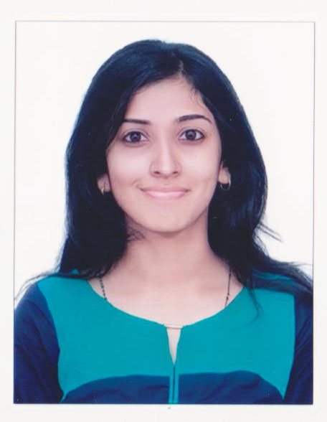Sumi Mary Chacko

Cochin

Mobile Number: 9995876405

Mail: sumixavier@gmail.com



**OBJECTIVES**

To be part of an organization’s Software development team and to welcome day-to-day challenges in a diligent manner. I endeavour to assist in all phases of planning, design, development, organizational projects.



**EDUCATION**



|  |  |  |
| --- | --- | --- |
| Year of Passing | Percentage Acquired | School/College/University |
| 2015 | 73.4% | B.Tech Computer Science and Engineering- Toc H Institute of Science and Technology - CUSAT |
| 2011 | 77.6% | 12th Grade – Our Own English High School, Sharjah, U.A.E |
| 2009 | 91.2% | 10th Grade – Our Own English High School, Sharjah, U.A.E |



**TECHNICAL SKILLS**

* Languages: C#, Java, PHP, JavaScript, SQL, jQuery, HTML5, CSS, Bootstrap
* Operating System: Windows 7, Ubuntu

Page **1** of **3**

Sumi Mary Chacko



**PERSONAL STRENGTHS**

* Ability to work conscientiously within a team or by self
* Prioritising tasks and capacity to multitask
* Goal oriented and self-motivated
* Flexible



**DEVELOPMENT / TESTING PROJECT EXPERIENCE**

*College Gym & Health Club Management System, 3rd Year B. Tech Project*

* The application was development in ASP.Net with C# incorporating Javascript, HTML and CSS. The

Worked on developing a user friendly website to manage a College Gym application. The website was modelled in three modules: Administrative Role, User Profile Management and Package Schedule and Payment.

The website was designed to facilitate registration through the online portal. Customers once enrolled could track details of gym schedules, available equipment and staff details. Payments for the packages could be made online. Staff users could update and manage member’s information. The Administrator role was created in a manner to monitor member and staff and finance details.

* Functional unit testing of application.

Worked on testing each of the modules to verify the logic and cohesion. We tested webpage functionality across web browsers such as Internet Explorer 9, Google Chrome, and Mozilla Firefox. We used the Web Developer toolkit, Chrome DevTools, Mozilla Firebug where applicable.

*Smart Meter, 4th Year B. Tech Project*

* Aims to build a GSM Based Smart meter.
* The application provides the customer and supplier an easy way to monitor energy. Consumers are able to make wise decisions on curtailing energy consumption and this in turn helps them to be savvy. This meter can measure the energy and send the information to the service provider. The service company can store this information and notify the consumer through SMS messages or through the internet.
* The embedded system will be developed as Embedded C program on MAPLAB compiler. The software part of it incorporates Netbean IDE 7.0.1 & Eclipse Juno for development of Android and Web Application. The back end will be developed with SQL Server 2008.

Page **2** of **3**



**INTERNSHIP**

*Trainee, Product Surf, Dubai (B.Tech curriculum)*

* Had a brief overview of the online classified website created by the company. The vision of the company is to serve businesses and the local crowd of UAE.
* As this position was part of a voluntary internship from college, and I sought to understand the day-to-day business proceedings.
* Few of the topics briefed on were SEO, Bulk Marketing (SMS & Emails) and Corporate Branding.
* The website was based on responsive design, providing optimal reading and navigation experience across the range of mobile, tablet and desktop.

 Sumi Mary Chacko



**PERSONAL DETAILS**

|  |  |
| --- | --- |
| Full Name | Sumi Mary Chacko |
| Date of Birth | 28 June, 1992 |
| Marital Status | Single |
| Passport Number | A 4313809 |
| Place of Issue | Abu Dhabi, UAE |





**HOBBIES**

* Reading
* Creative writing
* Music
* Traveling

Page **3** of **3**