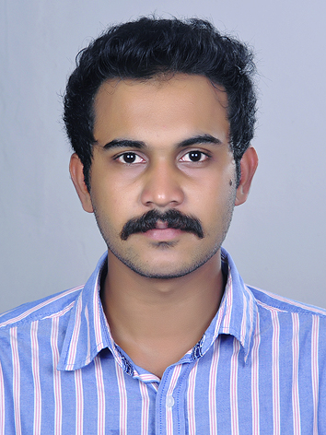

ARJUN . S
Tel:  +919645564322
E-mail: arjun96455@gmail.com
Skype : arjun96455@gmail.com

CAREER OBJECTIVE

To secure a promising, successful and challenging career in a reputed organization where my knowledge and skill can be effectively applied, enabling me to explore myself and realize my full potential.

Academic Profile
Year |  |  | Course/ University | Institution | Score
2014-2015 | m  ) |  | PGDM in Shipping and Logistics Management | Asia Mercantile & Maritime Academy, Cochin | 79%
2009-2013 |  |  | Bachelor of Business Administration (BBA) | MES College for Advanced Studies , Aluva | 55%
2009-2011 |  |  | Higher Secondary (Plus Two, COMMERCE) | Vaduthala Jama-ath Higher Secondary School | 77%
2008-2009 |  |  | Secondary School (10th) | St : Mary Of Leuca Central School , Cherthala | 59%

Previous Work Experience | Experience in SHIPPING DOCUMENTATION at Encore Pierian Logistics Business Services Ltd. Familiar with preparation of B/L, Commercial Invoice, Packing List, Shipping Bill, Bill of Entry, Certificate of Origin, etc.  Worked as Team Leader in Deliverz.

Technical Expertise
Computer Application  Operating Systems | : MS Office (Word, Excel, Access, PowerPoint).  OS : Windows XP, Windows 7, Windows Vista, Windows 8.

Skills & Hobbies
Languages |  | - English  - Malayalam  - Hindi
Strengths |  | - Disciplined, dedicated and hard working with an ability to easily adapt to changing work environment.  - Maintains good relationship.  - Zeal to learn new things and work innovatively.
Hobbies |  | - Driving  - Listening music

PERSONAL PROFILE:

Name : Arjun S
Address(Current Address) : House No : D1 , Police Quarters
Land Mark : Opp.to Hill Palace Museum,
Thrippunithura
Ernakulam (Dist)
Kerala
Pin: 682301
Gender : Male
Date of Birth : 18 Oct 1992
Nationality : Indian
Name of father : Sunil Kumar B
Name of mother : Ajitha Sunil

Declaration:
I do here by confirm that the information given in this form is true to do the best of my knowledge and belief.
Place: Ernakulam Date: 9-10-2017 ARJUN S

