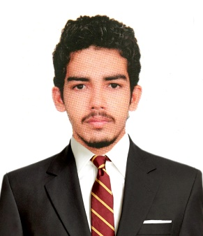CURRICULAM VITAE

**SANHAR M**

* [zanharchachi@gmail.com](mailto:mohdsharil46@gmail.com) +91 9745936738

**Career Objective:**

To enhance my working capacities, professional skills, business efficiencies to serve the organization in best possible way with sheer determination and commitment.

**Academic Qualifications:**

Course : MBA (Specialization: HR and MARKETING)

Year : 2014-2016

University : Bangalore University

College : Sambhram Academy of Management Studies, Bangalore

Course : B.com (Computer Application)

Year : 2011-2014

University : Kannur University

College : MES College, Kuthuparamba

**Professional Experience:**

Company : CADD Centre, Thalaserry

Designation : **MARKETING EXECUTIVE**

Duration : Dec 2016 to Mar 2017

**Duties and Responsibilities**

* Responsible for organizing marketing campaigns in the educational institutions.
* Assist the Department Head with regard to preparation of various reports.
* Responsible for taking seminars/presentation about software in different institutions.
* Regular meetings with Institutions and Company heads.
* Data collection of students and follow up.
* Conduct different marketing techniques to promote the softwares.
* Tie up with different consultancies for placement opportunity.

**Academic Project:**

**INTERNSHIP PROGRAMME**

Project title : A STUDY ON EFFECTIVENESS OF DISTRIBUTION STRATEGY

Environment : RUBCO HUAT WOODS (P) LTD. KERALA

Duration : 45 Days

**MINI PROJECT**

Project title : A STUDY ON BUYER BEHAVIOUR OF HOME APPLIANCES

Environment : BANGALORE

Duration : 30 Days

**Key Strengths:**

* Willingness to learn and Optimistic.
* Analytical and Sincere.
* Self-motivated and a good team player.
* Good interpersonal and Communication skills.
* Self-learning capacity.

**Key Skills and Computer proficiency:**

* Knowledge of Microsoft Office tools [**MS Word, MS Excel, and Power point**].
* Good logic in internet usage.
* Good knowledge of Online Social networking.
* Knowledge of E-commerce.
* Good knowledge of latest technologies and market trends.
* **Software’s:** Microsoft Office tools, Tally ERP 9.

**Key Achievements:**

* Participated in International passenger survey conducted at BANGALORE airport, Commissioned by Dept. of Tourism, Govt of INDIA.
* Participated in Student Conclave 2016, on the theme of ‘Dissertation Guidelines & Ideation to Executions’ organized at central college campus Bangalore in April 2016.
* Participated in Kannur district cricket team.

**Personal Details:**

Nationality : Indian

Gender **:** Male

Marital Status **:** Single

Passport Number : MO249599

Date of Birth **:** 05/09/1992

Languages Known **:** English, Hindi and Malayalam

**Declaration:**

I hereby declare that the information furnished above is true to the best of my knowledge.