**BIO-DATA**

**PERSONAL PROFILE**

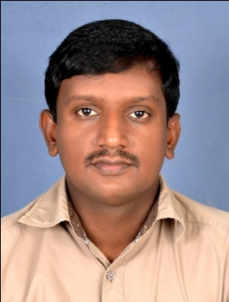

Name : Aneesh V R

Date of Birth : 24-05-1990

Gender : Male

Nationality : Indian

Religion : Hindu, Nair

Marital Status : Single

Father’s Name : V M Raveendran Nair

Address : Reji Nivas, Kavumbhagom P O

Cheruvally, Kottayam-686519

Contact No. : 9497320722

E-mail ID : aneeshvathalloor@gmail.com

Languages Known : Malayalam and English

**EDUCATIONAL QUALIFICATION**

1. Master of Communication and Journalism(MCJ) from MG University
2. BSc Physics from MG University

**WORKING EXPERIENCE**

1. Have worked in Deepika and janmabhumi dailies(Malayalam)
2. Working in an online news portal(infomagic.com), kottayam

**DECLARATION**

I do hereby declare that all the above statements are true and correct to the best of my knowledge and belief.

Place: Cheruvally

Date : 10-04-2017 S/d